Amazon is the most recognized name in the modern world, no matter which State you go to in the US or which country you visit. This enterprise has achieved great results in the past few decades. The product and supply chain established at Amazon is one of a kind that has been studied by many experts and has set a standard for others in the retail ecommerce arena.

DATA OVERVIEW

* DATASET:

The data used is historic and from Amazon available on the website <http://jmcauley.ucsd.edu/data/amazon/>.

* GOAL & QUESTIONS ASKED:

Picking the **Star Ratings (labelled as ‘overall’ in the dataset)** and checking the dependency on **Review WordCount and Product Category** as feature dependencies is an attempt to be quantified in this study.

Some of the questions asked are:

1. Does the wordcount in the review text matter? Do more words mean higher overall Star Ratings?
2. Do all Overall Star Ratings (1-5) have the same behavior across Product Categories i.e. Do Amazon Customers give more 1 stars to Baby products or more 5 stars to Android Apps?
3. Can we predict Overall Star Ratings given the word count of the review text?

This data compilation has 2 subsets namely 1. Reviews and 2. Ratings.

1. **Reviews Dataset**

The first dataset allows for us to get an understanding of Reviews that are product based and Reviewer ID based. and the derived feature called ‘WordCount_ReviewText’ will help bring about good insights as to how the customer’s review length and rating are dependent on each other. E.g. of the data types and counts is as follows:

<class 'pandas.core.frame.DataFrame'>

Int64Index: 228967 entries, 0 to 231779

Data columns (total 10 columns):

reviewerName 228967 non-null object

asin 228967 non-null object

overall 228967 non-null float64

reviewerID 228967 non-null object

reviewTime 228967 non-null object

unixReviewTime 228967 non-null int64

helpful 228967 non-null object

summary 228967 non-null object

reviewText 228967 non-null object

ProductType 228967 non-null object

dtypes: float64(1), int64(1), object(8)

memory usage: 19.2+ MB

1. **Ratings Dataset**

This second dataset we will use to define a timeline of the review and get the associated Star Rating dependency. Star Ratings maybe dependent on a seasonal, weekly or monthly cycle. Since the timeline of our data expands from 1996 to 2016, this should give us enough weeks, months and seasons to test out. The dataset is also segregated by Product Category, the Star Rating will be tested and predicted for each product category. e.g. Instant Videos, Apps for Android, Automotive etc. e.g. of the data types and counts is as follows:

<class 'pandas.core.frame.DataFrame'>

RangeIndex: 1324752 entries, 0 to 1324751

Data columns (total 5 columns):

reviewerID 1324752 non-null object

asin 1324752 non-null object

overall 1324752 non-null float64

unixReviewTime 1324752 non-null int64

ProductType 1324752 non-null object

dtypes: float64(1), int64(1), object(3)

memory usage: 50.5+ MB

CLIENT AND PROPOSED APPROACH

The ‘imaginary’ client could be Amazon trying to get an understanding of its customer base as to what leads to getting the customer to provide a good online review which then translates to a good overall rating and proportional sales increase due to popularity of a product. Currently in the retail world, tasks like product placement, inventory management, customized offers, product bundling etc. are being smartly handled using data science techniques.

Amazon could use this predictive analytical knowledge to decide which third-party vendors/sellers they would extend or end contracts with. Should Amazon continue or discontinue certain products, or this data would help decipher if product expansion needs to be considered based on customer reviews. So, this begs the question how do we conduct a meaningful analysis?

We start with a dataset that has product information, customer review timings and the actual customer initiated worded reviews. This last feature will help us extract the wordcount which we will use for our study extensively together with predictive analysis to predict the overall rating of a product based on the review given.

The overall approach will be to use graphs, conduct exploratory data analysis, use analytical tools, go through the inferential statistics stage and running machine learning algorithms which help decide on which algorithm will be the best fit and provide good results for predictive purposes.

IMPORTING RELEVANT PACKAGES & MODULES

A common practice that was adopted was to use aliases for the imported packages and modules. The following is a list of the packages and modules imported.

1. Pandas
2. Gzip
3. MatplotLib[ module pyplot]
4. MatplotLib[ module style]
5. Datetime
6. Calendar
7. Numpy
8. String [module Punctuation]
9. __future__ [module division]
10. Nltk.tokenize [module word_tokenize]
11. Nltk.tokenize [module sent_tokenize]
12. Nltk.tokenize [module regexp_tokenize]
13. Re
14. Seaborn
15. IPyhton.core.debugger [module Pdb]

DATA CLEANSING

Collecting the raw data from the website <http://jmcauley.ucsd.edu/data/amazon/> . The Reviews dataset had a total of 24 files that were ‘gzipped’ and in the JSON format. The Ratings dataset had a total of 24 files that were in CSV format. These files were segregated by ‘Product Category’ i.e. 24 and they are as follows:

|  |  |
| --- | --- |
| **Product Categories** | |
| Amazon Instant Video | Health and Personal Care |
| Apps for Android | Home and Kitchen |
| Automotive | Kindle Store |
| Baby | Movies and TV |
| Beauty | Musical Instruments |
| Books | Office Products |
| CDs and Vinyl | Patio Lawn and Garden |
| Cell Phones and Accessories | Pet Supplies |
| Clothing, Shoes and Jewelry | Sports and Outdoors |
| Digital Music | Tools and Home Improvement |
| Electronics | Toys and Games |
| Grocery and Gourmet Foods | Video Games |

DATA MASSAGING

Abstraction:

* Function to GUnzip a File
* Function to return a Dataframe from a JSON - Gzip file
* Function to Calculate Character Count in the ReviewText
* Function to Calculate Word Count in the ReviewText

Data Munging:

* Reading the Reviews into DataFrames
* Adding the Product Type Column to each DataFrame
* Adding individual DFs to AmazonReviews DataFrame List
* Labelling: Add Column Names to Ratings Dataframe since it is missing the Header
* Reading the Ratings into DataFrames
* Adding the Product Type Column to each DataFrame
* Adding individual DFs to AmazonRatingsDataFrame List
* Use Value_counts() to understand how many columns are of type object
* Printing Reviews and Ratings Dataframes
* Dataframe df_AzReviews[23] and df_AzRatings[23] Before dropna
* Dataframe df_AzReviews[23] and df_AzRatings[23] After dropna - Shows no change for Ratings row numbers
* Dataframe df_AzReviews - running the dropna method on the list of DFs
* Dataframe df_AzRatings - running the dropna method on the list of DFs
* Printing Reviews & Rating Dataframe Heads to check data integrity
* Printing Reviews & Rating Dataframe Tails to check data integrity
* Indexing: Setting the index for both dataFrame Lists i.e. Reviews and Ratings as 'reviewerID'

Sampling:

* For both datasets of Reviews and Ratings we would like to now take only a sample set of the entire DataSet. I have decided on a fraction= 0.5 i.e. 5 % of each Product category and appending them into one dataframe of Sample_AzReviews and Sample_AzRatings to give a total count of 9020370 and 40368768 records respectively.

Feature Engineering:

* Adding reviewertext features such as character_count and word_count to the Reviews dataframe list
* Adding helpful column features such as helpful_numerator, helpful_denominator and helpful_percentage to the Reviews dataframe list
* Adding time series features such as reviewYear, reviewMonth, reviewDate, reviewDayofWeek and ReviewWeekofYear to the Reviews and Ratings DataFrame lists.

DATA VISUALIZATION OF ENTIRE DATASET

|  |  |  |  |  |  |
| --- | --- | --- | --- | --- | --- |
| **Type of Plot** | **Dependent Variable** | **Independent Variable** | **DataSet/Product Category** | **# of Observations** | **Observation** |
| Scatter SubPlots | OverAll | WordCount_ReviewText | Sample_AzReviews Dataset:  Video Games | Head(100) | Rating 4 has higher wordcount. Rating 5 has the maximum records concentration in the 0 -100 range wordcount. |
| Scatter SubPlots | Overall | Helpful_Denominator | Sample_AzReviews Dataset:  Video Games | Head(100) | Rating 1 has the outlier with the maximum helpful_denominator i.e. helpful Factor at 54. |
| Scatter SubPlots -Tight Layout | OverAll | WordCount_ReviewText | Sample_AzReviews Dataset:   1. Instant Video 2. Android Apps 3. Automotive 4. Baby | Head(500) of each set. | The Baby Product Category got the most Ratings of 1 and 5 i.e. wordier reviews up to 700 wordcount. |
| Swarmplot | ReviewDate | Overall | Sample_AzReviews Dataset | Head(500) | More Reviews of Rating 5 were given in total, next maximum number of reviews given was towards Rating 4.  More Reviews were Rated in the first 20 days of the month. |
|  |  |  |  |  |  |
|  |  |  |  |  |  |
| **Type of Plot** | **Dependent Variable** | **Independent Variable** | **DataSet/Product Category** | **# of Observations** | **Observation** |
| Swarmplot | ReviewDayofWeek | Overall | Sample_AzReviews Dataset | Head(500) | datetime.weekday()--Return the day of the week as an integer, where Monday is 0 and Sunday is 6.  Overall Rating ->Popular Days  1 -> Tue, Fri  2-> Mon, Sun  3-> Tue,Thu, Sun  4-> All Days equal  5-> All Days equal |
| Swarmplot | ReviewMonth | Overall | Sample_AzReviews Dataset | Head(500) | Overall Rating ->Popular Months  1 -> Feb  2-> Feb, Apr, May (None in Dec)  3-> Feb, June (None in Nov)  4-> Least in Oct  5-> All Months equal |
| Swarmplot | ReviewYear | Overall | Sample_AzReviews Dataset | Head(500) |  |
| Swarmplot | Wordcount_reviewtext | Overall | Sample_AzReviews Dataset | Head(500) | The Ratings 4 and 5 have wordier outliers in 1000+ wordcount range. |
| Seaborn Heatmap |  | Overall  Helpful_numerator  Helpful_denominator  ReviewMonth  ReviewDayofWeek | score_Reviews_data | Head(10) |  |
| Seaborn Clustermap |  | Overall  Helpful_numerator  Helpful_denominator  ReviewMonth  ReviewDayofWeek | score_Reviews_data | Head(10) |  |
| Seaborn Pairplot | Overall  Charcount_reviewtext  Helpful_numerator  Helpful_denominator  ReviewMonth  ReviewDayofWeek | Overall  Charcount_reviewtext  Helpful_numerator  Helpful_denominator  ReviewMonth  ReviewDayofWeek | score_Reviews_data | Head(500) | CharCount of the reviews shows that the Star Ratings of 2, 4 and 5 are outliers and gravitate towards the wordier reviews (10,000+ characters). |
| Seaborn Pairplot | Overall  Charcount_reviewtext  Helpful_numerator  Helpful_denominator  ReviewMonth  ReviewDayofWeek | Overall  Charcount_reviewtext  Helpful_numerator  Helpful_denominator  ReviewMonth  ReviewDayofWeek | score_Reviews_data | Tail(500) | CharCount of the reviews shows that the Star Ratings of 2, 4 and 5 are outliers and gravitate towards the wordier reviews (6,000-10,000 characters). |

DATA VISUALIZATION BASED INITIAL FINDINGS

Typically one would guess that the WordCount of the reviews is the most or the least for Overall Star Ratings of 5 i.e. a Star Ratings when the best gets a ‘lot of praise’ or ‘is expressed in a few words’ – there are 2 extremes and this relates to human behavior directly of when being happy expresses oneself in either monosyllables or with a mouthful of words. The same goes for Overall Star Ratings of 1 which builds on the emotion of anger – one is either expressive in few words or the other extreme of being very wordy.

Question is then does Star Rating of 1 and 5 get the most and least word count association? Let’s look at the visuals that tell us a story:

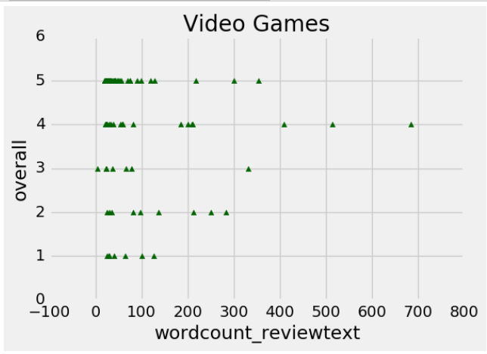

Observation: Rating 4 has higher wordcount. Rating 5 has the maximum records concentration in the 0 -100 range wordcount. **The lower wordcounts are focused across ALL Overall Star Ratings (1-5).**

Instant Video Android Apps

WordCount_reviewtext (X-axis) vs Overall Rating (Y-axis)

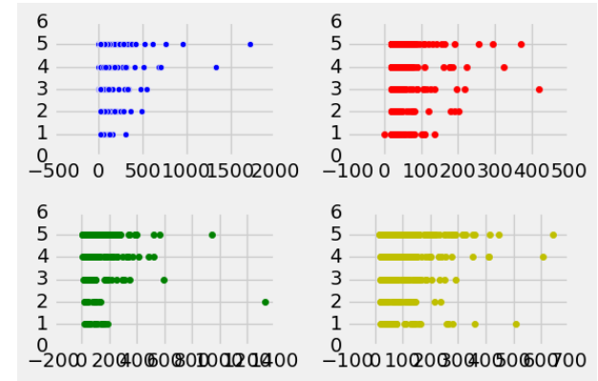

Automotive Baby

Observation: The Baby Product Category got the most Ratings of 1 and 5 i.e. wordier reviews up to 700 wordcount. All Product Types have the wordier reviews in the Star Rating 4 and 5 set. **The lower wordcounts are focused across ALL Overall Star Ratings (1-5) and Product Types.**

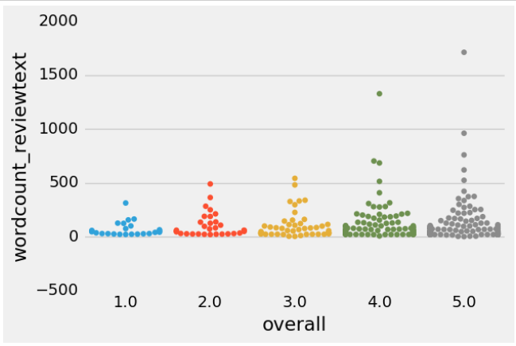

Observation: The Ratings 4 and 5 have wordier outliers in 1000+ wordcount range. **The lower wordcounts are focused across ALL Overall Star Ratings (1-5).**

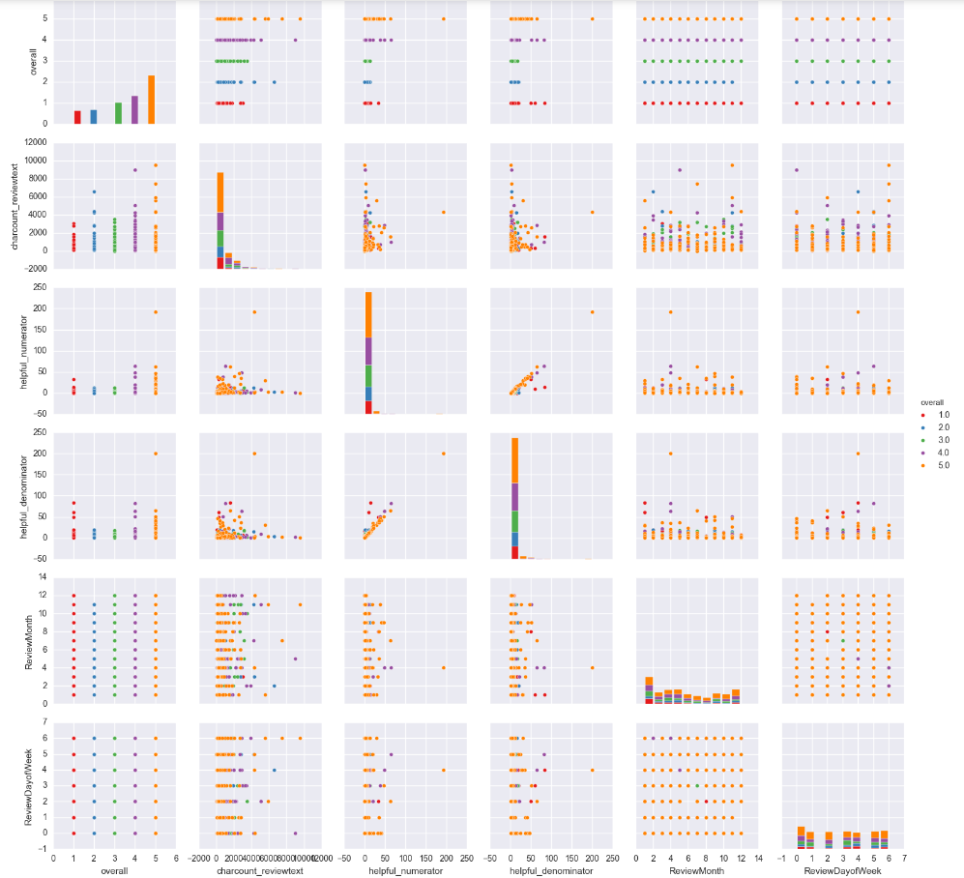

Observation: Of all the correlations, the Overall Star Rating vs the Charcount_Reviewtext shows that there is a direct relationship between these features in the above pair-plot. CharCount of the reviews shows that the Star Ratings of 2, 4 and 5 are outliers and gravitate towards the wordier reviews (6,000-10,000 characters). **The lower wordcounts are focused across ALL Overall Star Ratings (1-5).**

Finally, no matter which visual tool is used, or dataset is chosen, we see this across the board that the **lower wordcounts are focused across ALL Overall Star Ratings (1-5).** We had predicted that the 1 and 5 overall star ratings would see a low and high word count, from the visuals see the prediction come true only partially and there is a slight twist to it too.

**At this point we will try and answer some of the original questions:**

Q1. Does the wordcount in the review text matter? Do more words mean higher overall Star Ratings?

A1. Visually we see that the wordcount for each customer review does not matter because a lower wordcount is a trend seen across all Overall Star Ratings given, whether the customer gave a 1, 2, 3, 4 or 5. Visually higher counts for the text of the worded reviews is visually evident as being present for only the higher Overall Star Ratings (4 or 5). Statistically we see that the averages of the wordcounts seem to even out and the one-way ANOVA and Tukey’s tests both certify that the means of wordcounts are equal no matter which Overall Rating number is selected.

Q2. Do all Overall Star Ratings (1-5) have the same behavior across Product Categories i.e. Do Amazon Customers give more 1 stars to Baby products or more 5 stars to Android Apps?

A2. The averages of Overall Star Ratings across all Product categories (as seen from the box plot below) are different. For e.g. Android Apps and Baby products have lower average Overall Star Ratings compared to Automotive, Books and Digital Music. The ANOVA one-way test proves this statistically.

INFERENTIAL STATISTICS

The first action is to create the score_Reviews_data as the dataframe that provides all numerical data that will be used for further statistical analysis and ML algorithms. It has the following features:

* Overall – Star Rating from 1 through 5
* Asin - Unique Product Code
* CharacterCount_ReviewText – Number of characters in Customer Review Text
* WordCount_ReviewText – Number of words in Customer Review Text
* Helpful_Numerator – Count of Helpful (ThumsUp) given to a Customer Review
* Helpful_Denominator – Count of total Customer Reviews given
* HelpfulPercentage – Percentage calculated from Numerator and Denominator numbers.
* ReviewYear – Year when the customer review was given.
* ReviewMonth - Month when the customer review was given.
* ReviewDate - Date when the customer review was given.
* ReviewDayofWeek – Day of the week when the customer review was given.
* ReviewWeekofYear – Week of the year when the customer review was given.

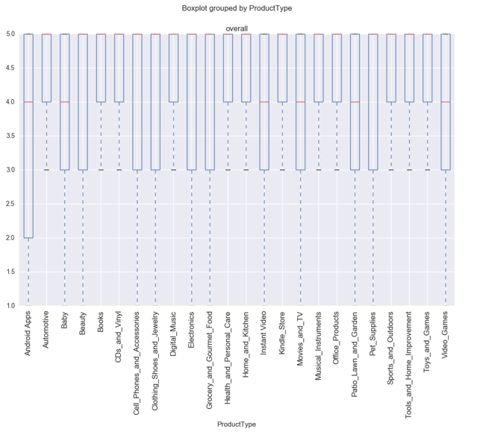

k= 24 (number of conditions)

N= 4681373 (conditions times participants)

n= 139608 (Participants in each condition)

The above boxplot shows that the means of the ‘Overall Star Ratings’ across all Product Types is different. Running the one-way ANOVA test and the Tukey test will either confirm or refute the findings.

The one-way ANOVA tests whether the mean of some numeric variable differs across the levels of one categorical variable. It essentially answers the question: do any of the group means differ from one another? The ANOVA test involves more calculations than the t-test, but the process is similar: you go through several calculations to arrive at a test statistic and then you compare the test statistic to a critical value based on a probability distribution. In the case of the ANOVA, you use the "f-distribution".

The SciPy library has a function for carrying out one-way ANOVA tests called scipy.stats.f_oneway(). Let's use the ANOVA to compare average Overall Ratings across the Product groups and Wordcount groups.

* Using 1 way ANOVA using statmodel where we will compare grouped reviews based on producttype i.e. Instant Videos, Video Games, Android Apps, etc.
* Using 1 way ANOVA using statmodel where we will compare grouped reviews based on wordcount i.e. [0,443,639,803,1284] etc.

(1) Hypothesis for the set of test data of **overall Star Ratings** against the **Product Type** of the reviewText:

H0: The average number of overall Star Ratings given for customer Reviews for each Product Type is equal.

Ha: The average number of overall Star Ratings given for customer Reviews for each Product Type is not equal.

**AND**

(2) Hypothesis for the other set of test data of **overall Star Ratings** against the **wordcount** of the reviewText:

H0: The average number of overall Star Ratings given for customer Reviews for each word_count category is equal.

Ha: The average number of overall Star Ratings given for customer Reviews for each word_count category is not equal.

Results [per Product Type]:

* + F_onewayResult(statistic=40.728777413441748, pvalue=1.754135462561985e-10)
  + After running the ANOVA test, the F-statistic is 40.728777413441748 and the p-value is 1.754135462561985e-10. Since the p-value is near zero we can reject the null hypothesis and conclude that the average number of overall Star Ratings given for customer Reviews for each product category is not equal.

|  |
| --- |
| df sum_sq mean_sq F PR(>F) |
| ProductType 1.0 0.183824 0.183824 0.079064 0.782412 |
| Residual 15.0 34.875000 2.325000 NaN NaN |

Results [per Wordcount Category i.e. [0,443,639,803,1284]]:

* F_onewayResult(statistic=1.00672268907563, pvalue=0.44181603711228229)

After running the ANOVA test, the F-statistic is 1.00672268907563 and the p-value is 0.44181603711228229. Since the p-value is not near zero we cannot reject the null hypothesis and **conclude that the average number of overall Star Ratings given for customer Reviews for each word_count category is equal.**

* The test result suggests the groups don't have the same sample means in this case, since the p-value is significant at a 99% confidence level. To check which groups differ after getting a positive ANOVA result, you can perform a follow up test or "post-hoc test". One post-hoc test is to perform a separate t-test for each pair of groups. You can perform a t-test between all pairs by running each pair through the stats.ttest_ind(). The table below shows since the p-values are not below 0.05 we cannot reject the null hypothesis and **conclude that the pairs’ mean values are equal.**

|  |  |
| --- | --- |
| **WordCount Pairs** | **Ttest Results** |
| 0 443 | Ttest_indResult(statistic=-0.78446454055273618, pvalue=0.46260543015431632) |
| 0 639 | Ttest_indResult(statistic=-1.1239029738980328, pvalue=0.30399938256846926) |
| 0 803 | Ttest_indResult(statistic=0.57173115475474245, pvalue=0.59224601604340843) |
| 443 639 | Ttest_indResult(statistic=0.0, pvalue=1.0) |
| 443 803 | Ttest_indResult(statistic=1.2518642814237004, pvalue=0.26599088513252928) |
| 639 803 | Ttest_indResult(statistic=1.9720265943665387, pvalue=0.10564980084735728) |

Tukey’s range test, named after the American mathematician John Tukey, is a common method used as a post hoc analysis after the one-way ANOVA. This test compares all possible pairs and we can use it to precisely identify pairs where the difference between two means is greater than the expected standard error.

For each pair of mean values:

H0: The means are equal.

Ha: The means are not equal.

The result below shows each pairs’ mean difference. Since the pair’s mean values are not statistically significantly different, then we cannot reject the null hypothesis and **conclude that the pairs’ mean values are equal**. In the table below, the ‘reject’ column has a False value.

|  |
| --- |
| df sum_sq mean_sq F PR(>F) |
| wordcount_reviewtext 1.0 0.577909 0.577909 0.251404 0.623367 |
| Residual 15.0 34.480915 2.298728 NaN NaN |

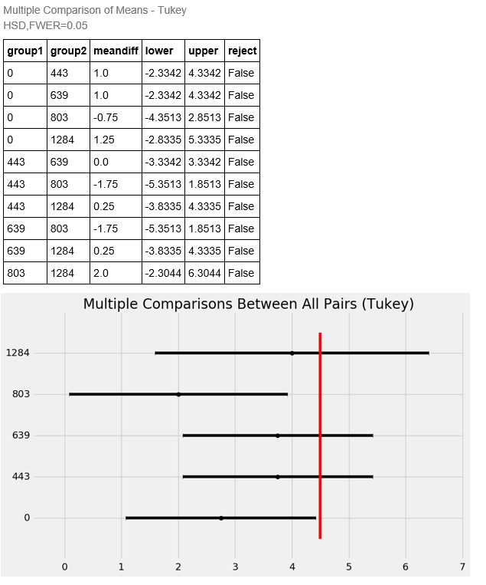

MACHINE LEARNING MODELS AND PREDICTIVE ANALYSIS

* KNN CLUSTERING MODEL
* LINEAR REGRESSION MODEL
* NAÏVE BAYES MODEL

NLTK and NLP PROCESSING OF REVIEWTEXT DATA